MAST 5112

Poe

Part 1 A document containing all the screen designs.

Faraaz Mahomed

ST10446912

A document containing all the screen designs.

Figure 1 HomeScreen

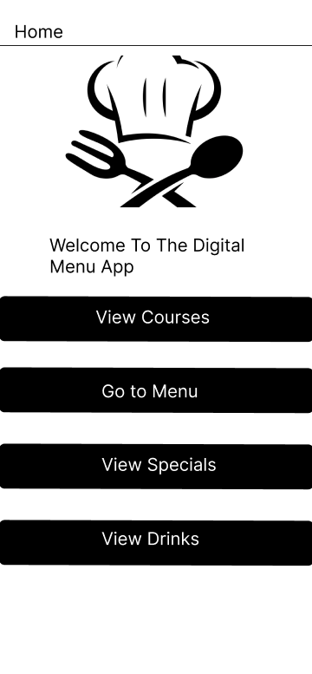

* Header: The word "Home," placed simply at the upper portion of the screen, signifies that the user is currently on the application's home page. Logo/Icon: A sizable, center icon with a chef's hat and a crossed fork and spoon sits beneath the header. This icon provides users with an instant visual clue regarding the app's purpose, presumably representing its focus on food or dining. Greetings Text: "Welcome to the Digital Menu App," is the phrase that appears beneath the symbol. This text greets users and provides an introduction to the app. Buttons: Four buttons, each with a unique label, are stacked vertically:
* **View Courses:** Likely leads to a page where users can browse different food courses or categories.
* **Go to Menu:** Probably takes users to the full menu of available dishes or items.
* **View Specials:** Likely displays any special offers or featured dishes.
* **View Drinks:** Opens a section dedicated to beverages.

The client can press the button and the client will go to the page that was pressed and continuous from there.

Figure 2 Courses Screen

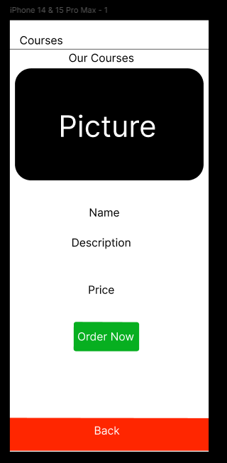

The screen grab you submitted is from the "Digital Menu App," more precisely from the "Courses" section. The heading at the top, "Courses," denotes the area of the app that is currently open. The heading is followed by a subheading called "Our Courses," which implies that the content is centered around particular meal courses or services. A placeholder labeled "Picture," which normally displays an image of the dish or course, takes up most of the central portion of the screen. There are fields for the course's "Name," underneath the placeholder image.

"Description," and "Price," which offer crucial information about the meal. Users can place an order right from this screen by clicking the large green "Order Now" button. To ensure seamless navigation, a sizable red "Back" button at the bottom gives users a simple option to go back to the previous screen. Users will find it simple to browse and order courses within the app because to its minimalistic design, which places a strong emphasis on practicality and user accessibility.

Figure 3 Chefs Screen

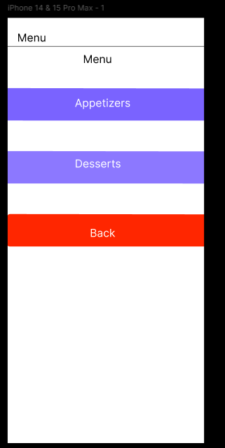

It shows a "Menu" screen from the "Digital Menu App." The screen's arrangement is straightforward and uncomplicated, including a "Menu" banner at the top that denotes the app's area. Two sizable buttons with the labels "Appetizers" and "Desserts" clearly visible beneath the header are each painted a gentle purple hue, making them easy to tap and visually distinguishable. These buttons most likely take customers to additional screens where they can go deeper into each category's individual products. A prominent red "Back" button at the bottom of the screen provides an easy method to go back to the previous screen. The general layout places a strong emphasis on simplicity and use, enabling users to locate and choose the kind of menu items they want to explore.

Figure 4 Dessert Screen

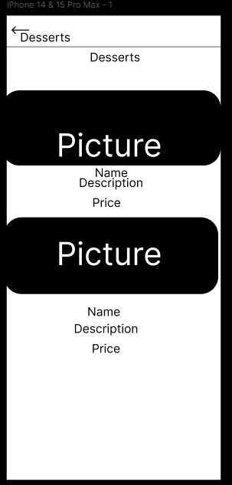

A wireframe of a mobile application screen for a menu item named "Desserts" appears to be depicted in the image. The design features a top navigation bar labeled "Desserts" with a back arrow. Below that are two sections with an image placeholder each, and then the text fields "Name," "Description," and "Price." The layout most likely aims to highlight certain dessert products, providing room for an image, name, price, and a brief description of each dessert. The labels and placeholders imply that this is a preliminary design intended to direct the creation of the user interface for the app.

Figure 5 Drinks Screen

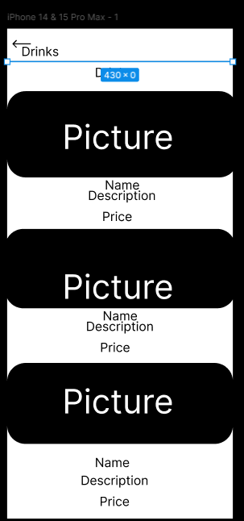

This picture is an additional wireframe or mockup of a screen for a mobile application, with an emphasis on the "Drinks" area. The layout is identical to the previous version, with a top navigation bar that has a back arrow and the word "Drinks." There are three parts below the navigation bar, each intended to highlight a different drink item. After a space for an image, each section has text fields with the labels "Name," "Description," and "Price." With room for a picture of the drink, its name, a brief description, and its price, this arrangement aims to serve as a visual indication for how drink products will be displayed in the app. The design proposes a well-structured, swiping list of beverages for effortless user navigation and selection.

Figure 6 Specials Screen

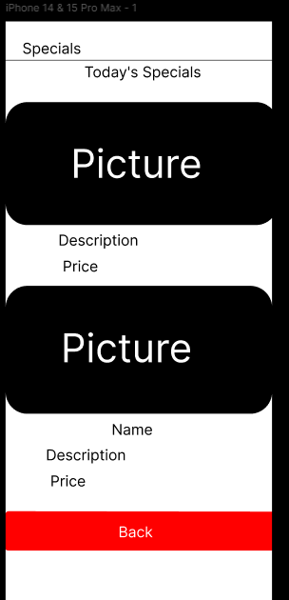

This picture is a wireframe or prototype of a "Specials"-focused mobile application screen. There is a navigation bar at the top of the layout that says "Specials." Below this is a section titled "Today's Specials," which suggests that things that are currently on sale will be displayed here. The prototype has two areas where each unique item can be shown. The first area has a space for an image and is followed by text boxes that are marked "Description" and "Price." A new text field with the caption "Name" appears above the fields for the description and price in the second section.

A large red "Back" button at the bottom of the screen indicates that this screen is a part of a flow where users can return to a prior menu or segment. The layout proposes emphasizing exceptional dishes or limited-time deals in an orderly and understandable way.

Reference list:

Figma (2016). *Figma: the Collaborative Interface Design tool.* [online] Figma. Available at: https://www.figma.com/.

‌

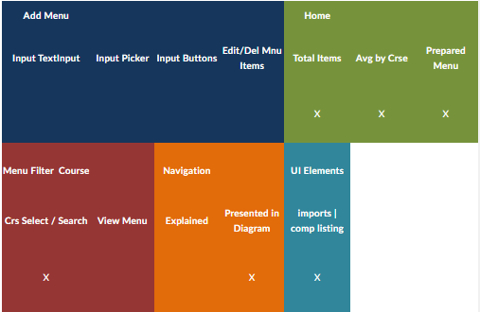

Part 2 what I have fixed for the app requirements in in the POE.

Changes made for the app for the chef

 Added a login page as requested by the lecturer

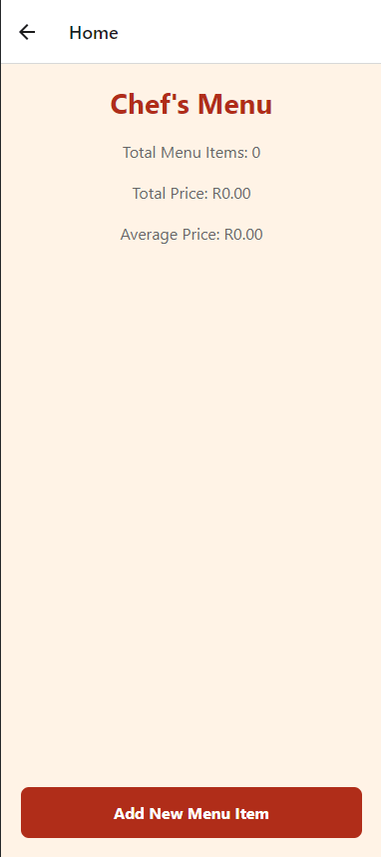

Chefs menu where the chef can see what the clients has ordered

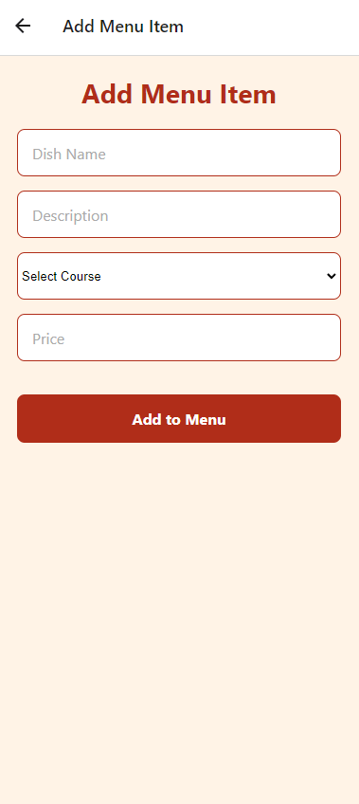

The clients can add a menu item

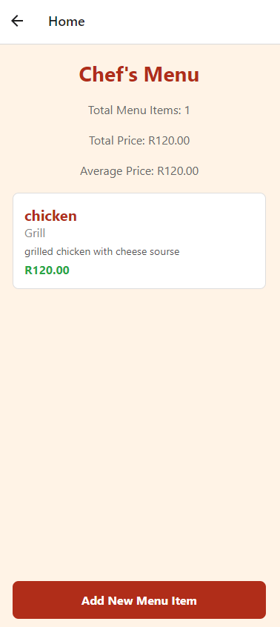

Order list what the chef can see

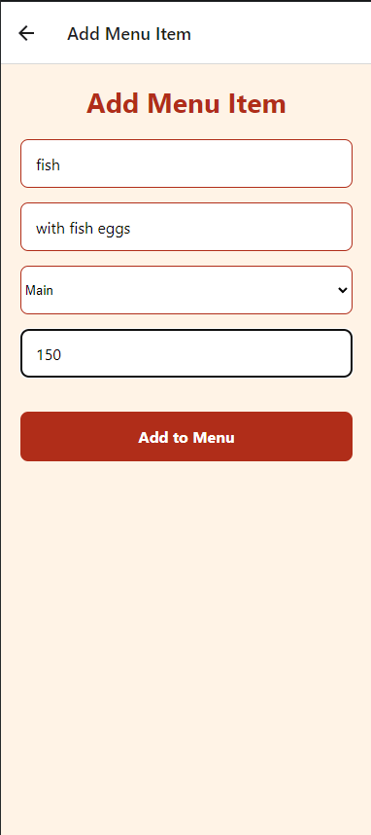

Add a menu item of your choice